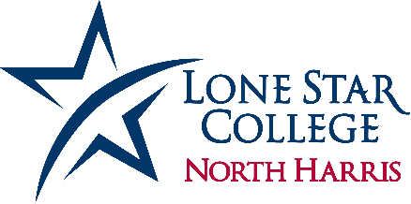

Lone Star College-North Harris launched the nationally recognized PUENTE Program fall of 2019. PUENTE is an award-winning program that for more than 30 years has improved the college-going rate of tens of thousands of California's educationally underrepresented students. PUENTE is designed to help students adjust to college life and prepare for transfer to a four-year university.

The program has three major components: accelerated writing instruction, advising and mentoring. Students have their own classes and their own counselor. Every semester, students are matched with professionals from the community who can provide them with knowledge and guidance about education, career and life. PUENTE provides its students with a strong academic foundation, essential for success at LSC-North Harris and four-year universities.

The PUENTE Program is co-sponsored by the University of California Berkeley.

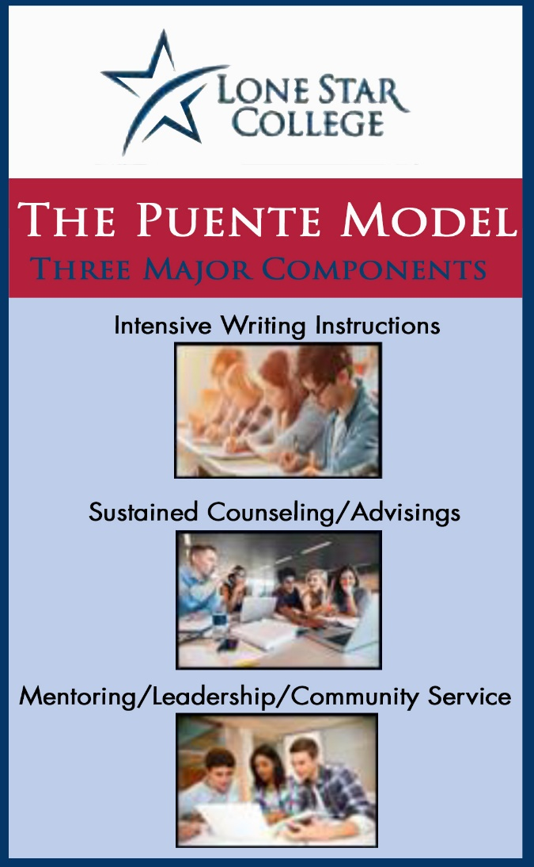
Enhance reading and writing skills
- Meet with professionals in our community*
- Learn strategies for college success and life
- Create a successful university transfer plan
- Participate in culturally enriched activities
- Receive dedicated registration
- Engage in hands-on active learning

The PUENTE Program is open to students who are:
- Planning to transfer to a four-year university.
- Eligible to enroll in college English and Math in the fall semester.
- Able to commit to program requirements.
- Able to be full time student (enrolled in 12 credits or more).

Fall Semester

- EDUC 1300 Learning Framework
- ENGL 1301 Composition and Rhetoric I
- HIST 1301 U.S. History 1877
- Fourth Class-Chosen from core curriculum by student and advisor

Spring Semester

- ENGL 1302 Composition and Rhetoric II
- HIST 1302 U.S. History 1877
- Third and Fourth Class-Chosen from core curriculum by student and advisor
For additional information, please contract LSC-North Harris PUENTE Coordinator
Rosemary Cuellar at 281.618.5577, Rosemary.Cuellar@LoneStar.edu.

*Due Covid 19, changes may be necessary.

