 | Searching the Library Catalog | LSC - Montgomery Library  3200 College Park Dr. Building F  Conroe, TX 77384  http://www.lonestar.edu/library  936-273-7390

Searching the catalog is simple and easy! Follow these steps:

1. Go to the library catalog website: http://librarycatalog.lonestar.edu/
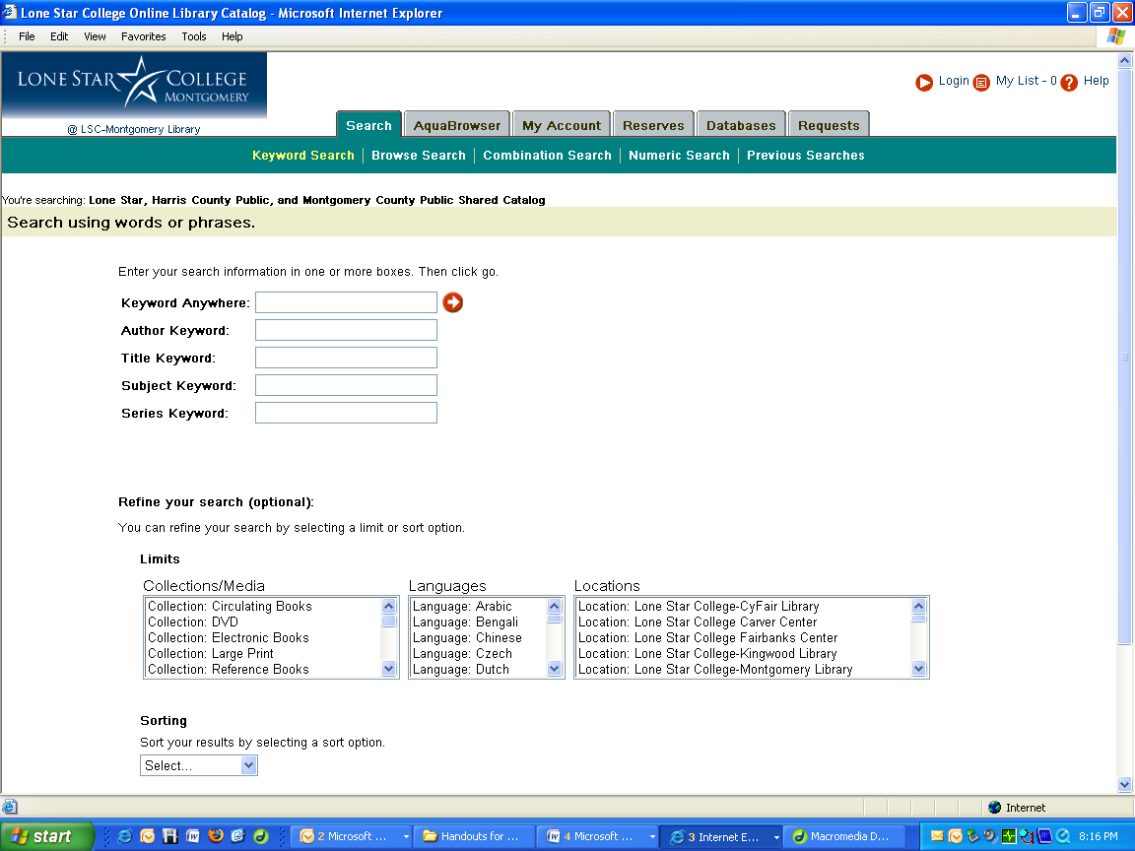
To search for books at a particular library, use the drop-down arrow under “Locations” to select a library.

The catalog contains a listing of all books at the libraries in the Lone Star College system, the Montgomery County Public Libraries and the Harris County Public Libraries.

2. In the search box, type in the subject or topic you are trying to research. In this example, we are searching for materials on gun control in the LSC-Montgomery
Library.
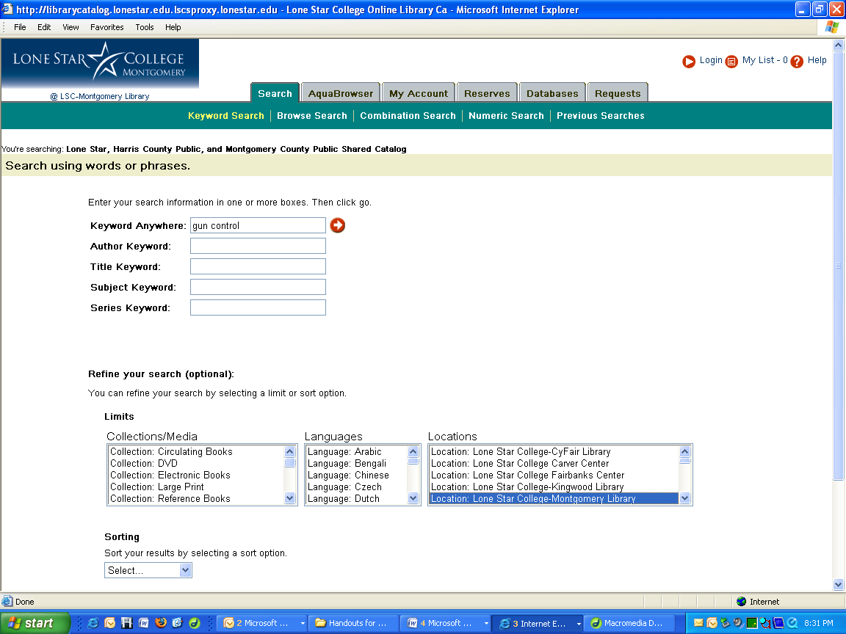

4. After clicking on “enter” or the white arrow in the red circle, we see that there are 35 books on gun control at the LSC-Montgomery Library.

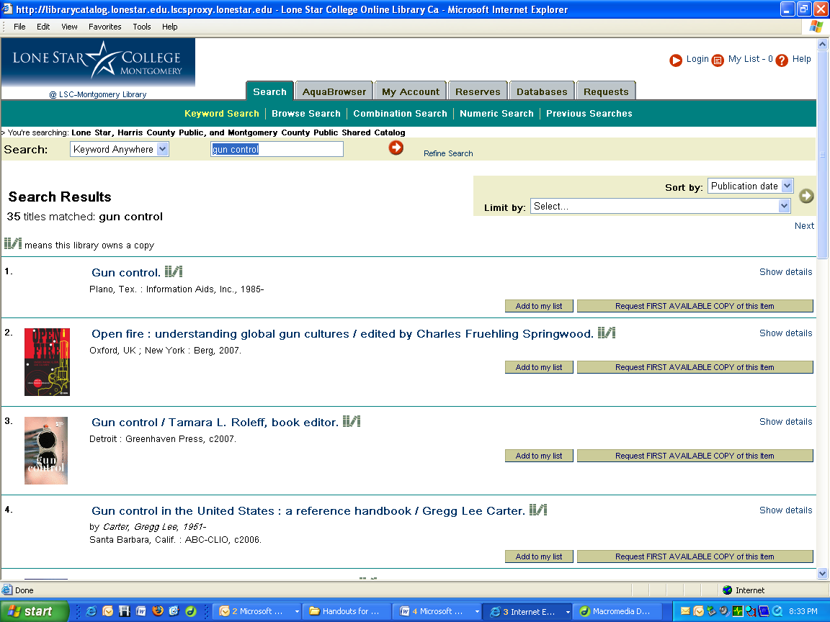
5. To check out a book, click on one of the blue titles. For example, click on Gun Violence,, the fifth title down.

6. The last step is to determine the status of the book, whether it is a circulating book or a reference book, whether it is checked in or out, or is on order or is missing.
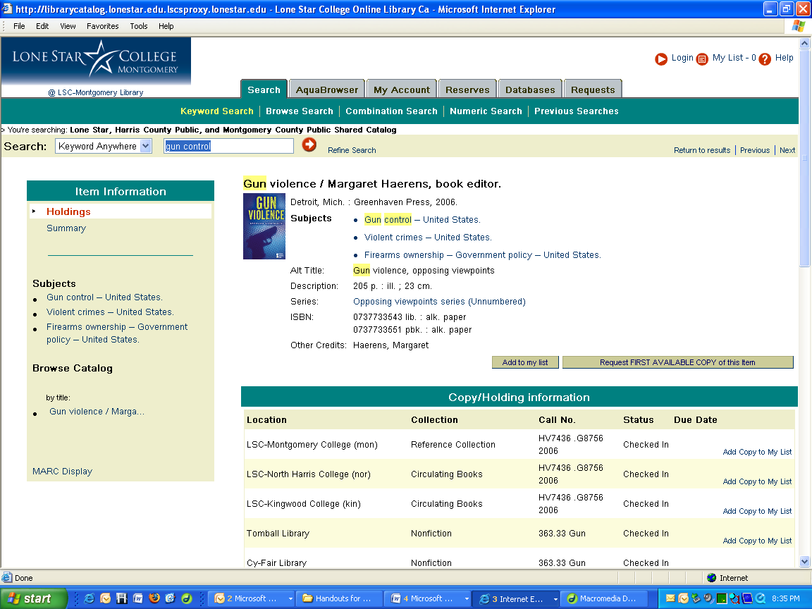

7. If you have successfully located a book that is available, write down the call number and go to the circulating book shelves. Then take the book to the circulation desk to check it out.

