Faculty Senate Agenda April 8, 4:00-5:30
Dr. Blanson 4:01- 4:05
-RTB is going through an update
-Can fill water bottle
-No café or cafeteria opening
-vending machines available
-Drive-thru graduation
-no change in the summer schedule in terms of bringing people back to work
-Modified return to campus possibly Fall 2021
-offer more face-to-face classes
-working on the remaining funds
-Review the SRP information
-budget process for next year

Dr. Yannuzzi 4:06- 4:11 ish
-might reach RTB 1.9 during Fall 2021
-consider what we can learn from this experience this past academic year to determine what to disregard or push forward with

OTS Randall Paulk 4:15-4:20ish
-U-Drive concerns
-the main reason for the move is because you can access the files from any device
-notify OTS if you need to save your files to the new drive

Student success and advising Reyna Tippets- 4:20
-resources are available from Reyna regarding registration, graduation, and advising, including Communities in School and other relevant offices:
-https://documentcloud.adobe.com/link/track?uri=urn:aaid:scds:US:152ff4d8-e114-4f49-bae8-32aad2837e4d
-https://documentcloud.adobe.com/link/track?uri=urn:aaid:scds:US:2fb674e3-dbd8-47b2-8b46-f76129a40ecf
-https://mylonestar-my.sharepoint.com/:w:/g/personal/kimberlee_h_ball_lonestar_edu/ES2mZTu_xVdFnsW_HKnQRA0BHGB3FL_-KDeT3VEAMHVAtg?e=BnGswJ
-encourage students to register for classes around the end of the semester and during open registration season
-advising works with faculty to help their courses make

Student Life Kelsey Jackson 4:30
-Student Leadership Awards
-let Kelsey know if a student is deserving of a student leadership award to recognize them
-averaging about 5 students per semester for the student leadership activities
-several Registered Student Organizations are still actively involved
-Link to the Student Life Virtual Events: https://www.lonestar.edu/2432

Christine Ramsey- Library Services 4:35
-worried about students needing to take a test during certain timeframes
-limited staff in the library
-provided videos for students to watch such as Maker Space and Adobe Spark
-Christine will do a professional development session on the One Drive

Committee Chairs Updates
Student Emergency Committee Chairperson—Erin Ranft
-some available funds left

Faculty Emergency Committee Chairperson—Shirley Ennis
-system-wide account now
-balance of $15,000

Professional Development Committee Chairperson—Julie Duncan
-June and July Faculty Summer Institutes
-Faculty Institute on 8/24
-Adjunct Bootcamp on 8/28

Awards Committee Chairperson—Janice Hartgrove-Freile- vote
-Conduct the awards process in the Fall instead of both semesters for full-time and adjuncts
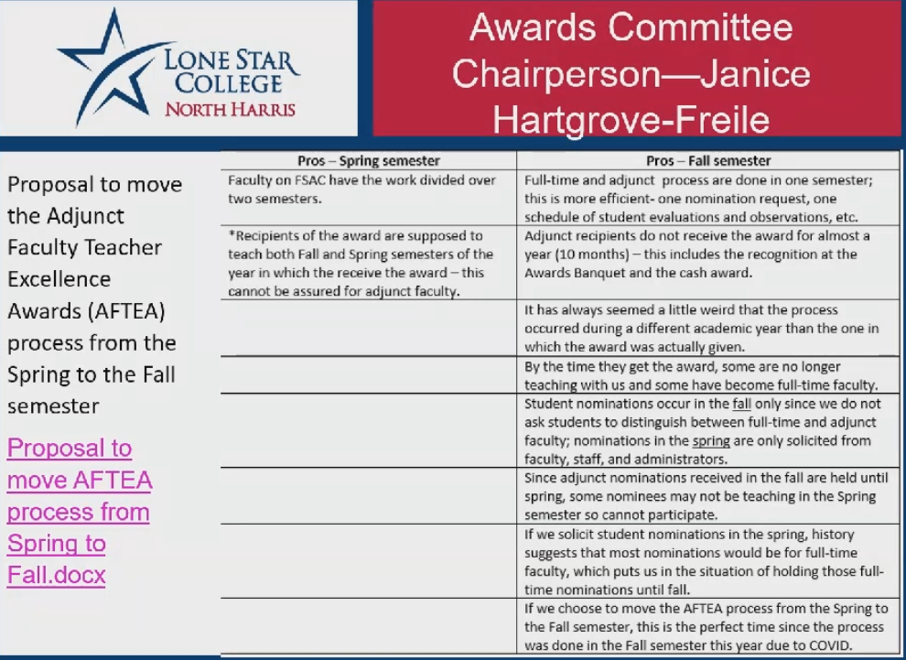
-motion approved

Task Force and other Updates
Foodbank up -date
-not currently operational
-partnering with Communities-in-School for a food drive
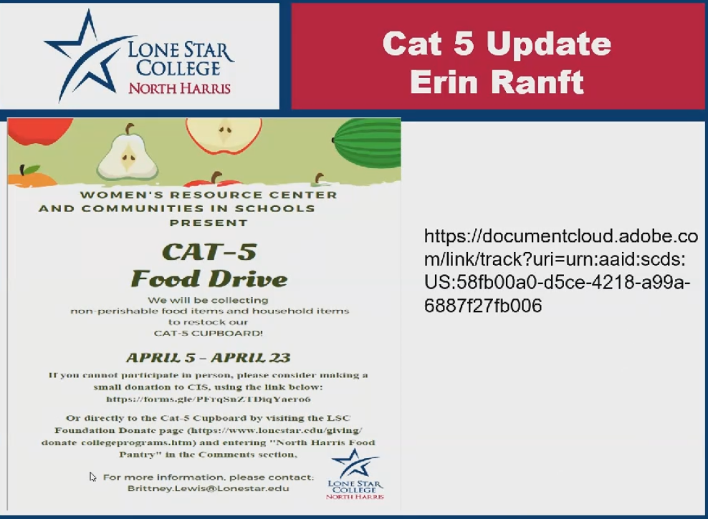
-one day a week appointment so students can collect necessities

-Bruce Martin – Land Acknowledgement
-no response yet
-use the land acknowledgment in three events last week
-had students read the document
-have a vote eventually on land acknowledgement
New Topics
Campus wide syllabus template. Several other campuses have a syllabus template where full and part time faculty input their course information and use it for their classes. This means that all the students understand the flow of the syllabus and helps part time faculty understand the important elements of a syllabus. North Harris does not have one. Do we want to form a committee to create one? Should this be at the department level? Something similar up front and department special after that?

Questions about proctoring services: What is your preferred platform for proctoring exams?
Revisited Topics
What did your fellow faculty say about their use of Brain Fuse?

