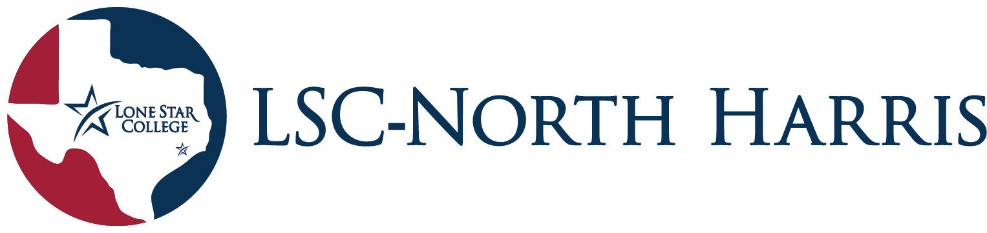
Student Government Association (SGA)
SGA General Assembly Meeting Minutes
November 29nd , 2023
12:00 pm – 12:45 pm
Student Center 2nd Floor, Room 204

- Call To Order-12:01
- Roll Call In ~(attendance at end of minutes)~
- Officer Reports
- President – Community service Project
-We will be handing out grocery and hygiene bags for our community service project. Flier on more details to be released to Instagram page.
- Secretary - C.Q.C box update
-The C.Q.C box is up so you can voice your comments, questions, and concerns.
We look forward to hearing from you.
(located within the entrance hallway to the student center on the second floor, small blue drop box with the title card)
- Akademos Interactive question sheet
- Entails of a short form to ask your questions and concerns for Akademos so we can communicate that to them and get their information/responses back to you through our Instagram page.
- The SGA E-board will share the information that we are given by Akademos’ responses at the next general assembly meeting in SPR24.
- Announcements
- Stem Club- has two more meetings before the semester ends-Thursdays from 1-2 Pm.
- First gen- last club meeting of semester 11/30 in ACAD 113.
- Student engagement and student services- BinGlow for 4 PM was announced. Located in the student center.
- Art sale will take place on December 5th and 6th. The reception starts at 9am, Break at: 11-2PM.
- Kahoot SGA quiz
- The top three winners will receive a pizza party. The Kahoot quiz was over general SGA knowledge.
- They are Sage Phillip, Kai Brownlow, and Jay Coyle. We congratulate them and everyone else for participating in the activity.
- Roll Call Out
- Adjournment-12:39PM

Roll call in attendance
- English club
- Visual Artist’s Association (V.A.A.)
- Student Ambassadors
- Phi Theta Kappa
- Pride Alliance
- Psi Beta
- STEM Club
- International Student Alliance (I.S.A.)
- Earth Alliance
- First Gen Club
- Anime & Gaming Club
- Film Club
- Business 4 Success
- Cosmetology Club
- Criminal Justice Student Association (C.J.S.A.)
- Future American Sign Language Interpreters (F.A.S.L.I.)
- Hurricane Men's Basketball Club
- Hurricane Men's Soccer Club
- Hurricane Volleyball Club
- Hurricane Women Soccer Club
- Latin American Student Organization (L.A.S.O.)
- Paralegal Association
- Student Activities Team
- Student Government Association
- Student Nurses Association (S.N.A.)
- Marichi Band Club
- Chess club
- Tabletop gaming club

