Find Username and Create Password with Student ID
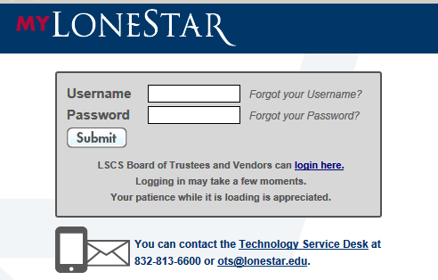
Username:
- Go to my.LoneStar.edu
- Click Forgot your username?

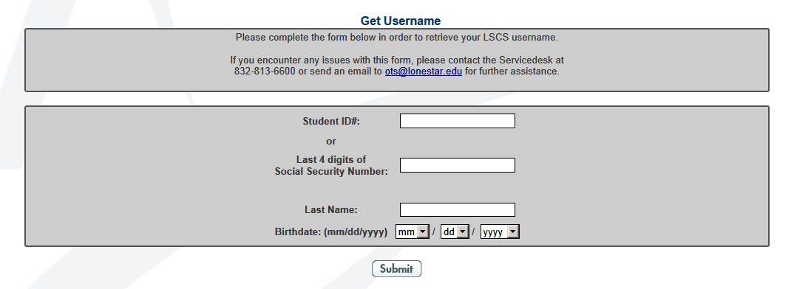
- Enter Lone Star student ID
- Skip Social Security Number box
- Enter your Last Name
- Enter your birthdate
- Click Submit

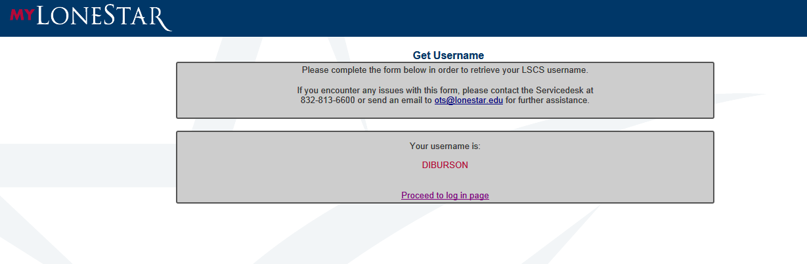

- Write down Username
- Click Proceed to log in page

Set or Reset Password

- Click Forgot your password?

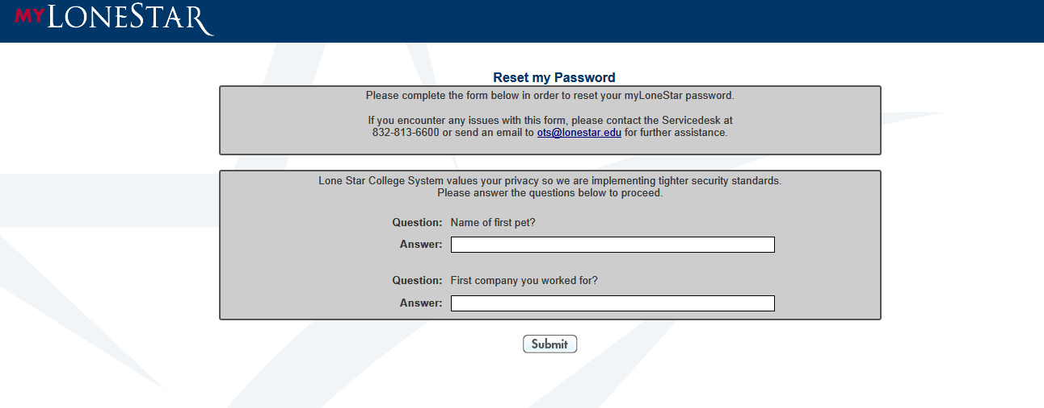
- Choose and answer security questions. NOTE: security questions are case sensitive – remember how you enter your answers
- Click Submit

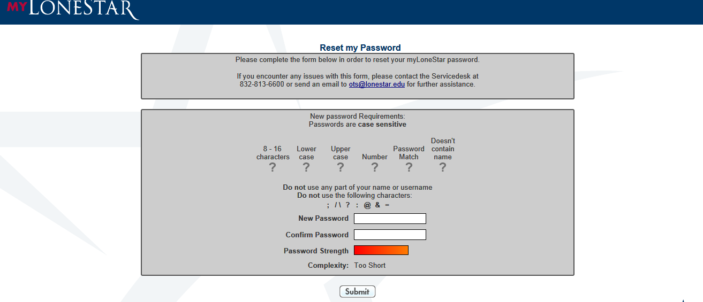

- Follow directions to create your password
- Click Submit

By clicking Submit you will return to the log in page. Log in to myLoneStar with your username and new password. Follow these directions to update or change your password at any time.

