Solving Linear Systems Using Matrices
Row Operations w/TI83+

Example:
Use matrices to solve the system:

Write the aumented matrix for the system:

TI83+
- Press MTRX
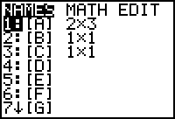

- Press EDIT and enter the dimensions for the system (2 X 3)
- Enter the values from the augmented matrix above
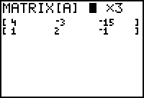

- Press MATRX, MATH
- Press the up arrow to see the row operations choices
- Press rowSwap(
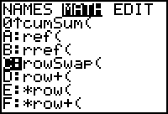

- rowSwap( will appear on your home screen
- Your calculator expects to see rowSwap(matrix,rowA,rowB)
- It swaps rowA and rowB of matrix
- Press MATRX, choose the name of the matrix you’re using ({A}) for our example, press the comma key, enter the number of the row to swap (1 for our example), press the comma key, enter the number of the row to swap to (2 in our example) and press the enter key
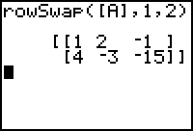

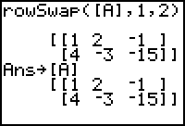
- Now you need to store the change in matrix A
  - Press the STO key, MATRX, [A]
  - Press the enter key

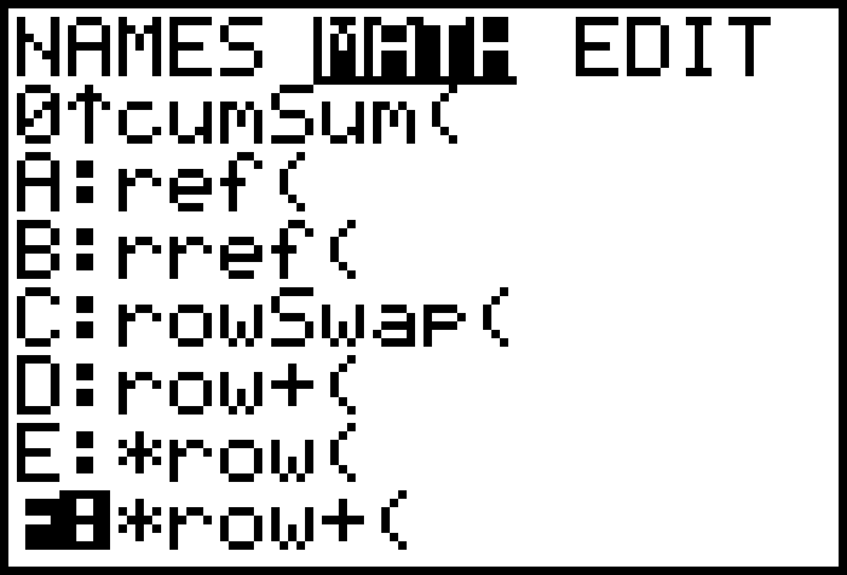
- You want the first element in row 2 to become zero
  - Press MTRX, MATH, arrow up to *row+(

- *row+( appears on your home screen
- The calculator expects the following
  - *row+(value, matrix, rowA,rowB)
  - It multiplies rowA of matrix by value, adds it to rowB, and stores the results in rowB
- Enter the value to multiply by (-4 in our example), press the comma key, enter the name of the matrix you’re using (matrix A in our example), press the comma key, enter 1 for rowA, press the comma key, enter 2 for rowB and press the enter key.
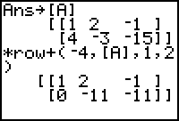

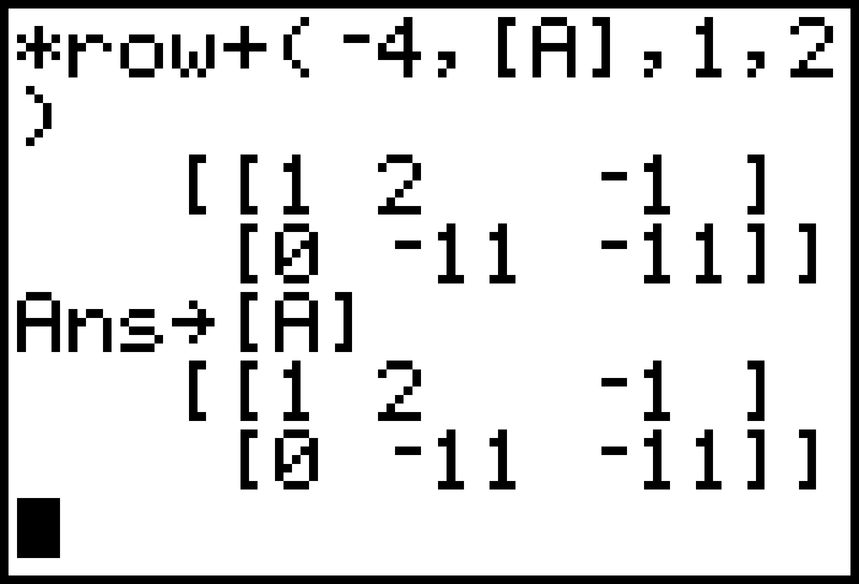
- You need to store this change in matrix A again
  - Press the STO key, MATRX, [A]
  - Press the enter key

- Now you need the second element in row 2 to become a 1
  - Press MMATRX, MATH, the up arrow, and choose *row(
  - *row( appears on your home screen
  - The calculator expects the following
    - *row(value,matrix,row)
    - Enter -1/11 for the value
    - Press the comma key
    - Press MATRX, choose [A] (or whatever matrix you are using)
    - Enter the number of the row to multiply times (2 in our example)
    - Press the enter key and the finished augmented matrix appears on your home screen
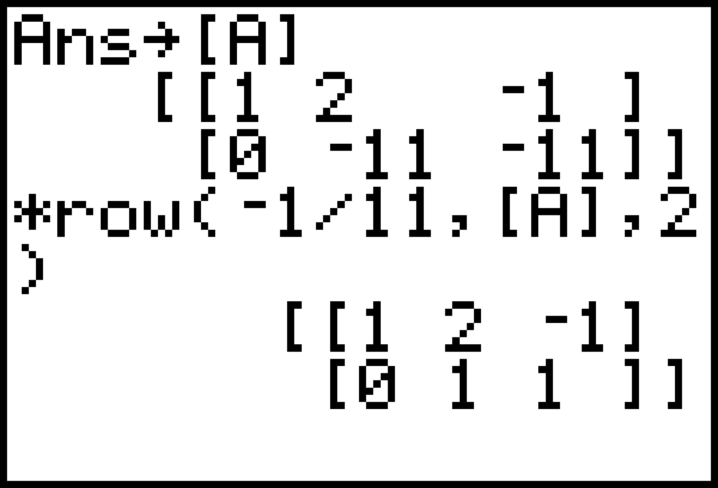

- Rewrite the system of equations with the above information:

- Substiture the value for y in the 1st equation

- Solve for x

