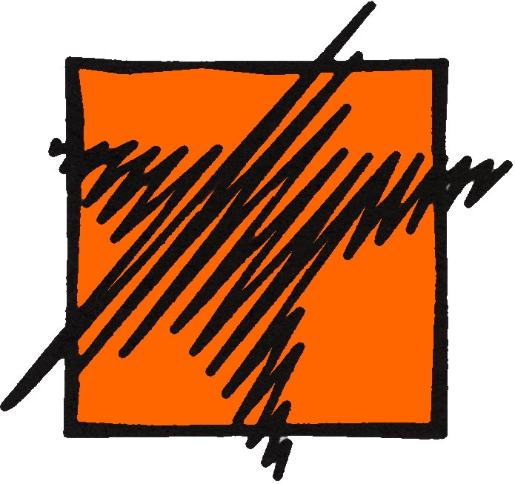
Cy-Fair College Language Labs
Basic Operation of Sony Soloist

What is Sony Soloist?

Sony Soloist is a computer program running on all student stations in the language labs. You will notice that some of the buttons look like those on a regular cassette recorder: this is because this program has a digital recorder feature.

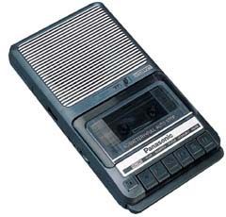


Sony Soloist will allow you to do all of these same operations digitally, that is to say, on a computer & without a cassette!

What’s Sony Soloist used for, and how do I find it?

Of course, instead of pressing tape recorder buttons with your finger like you do on a portable cassette recorder, in Sony Soloist, with the computer’s left mouse button, you move the mouse arrow on the screen over your function choice and left-click on it.

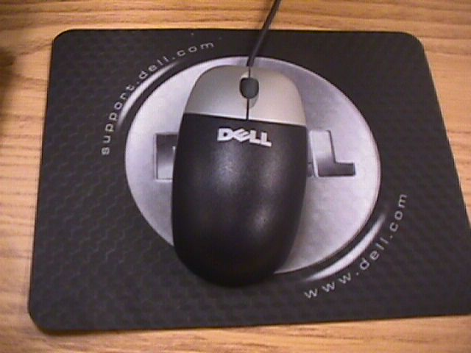

How do I log in?

Once you are logged on to your computer station and you are ready to begin your recording activities follow the steps here in order to launch Sony Soloist.

1. On the left hand side of your computer screen you will find a yellow speaker icon. Double-click on it using the left mouse button to launch the login window for Sony Soloist.
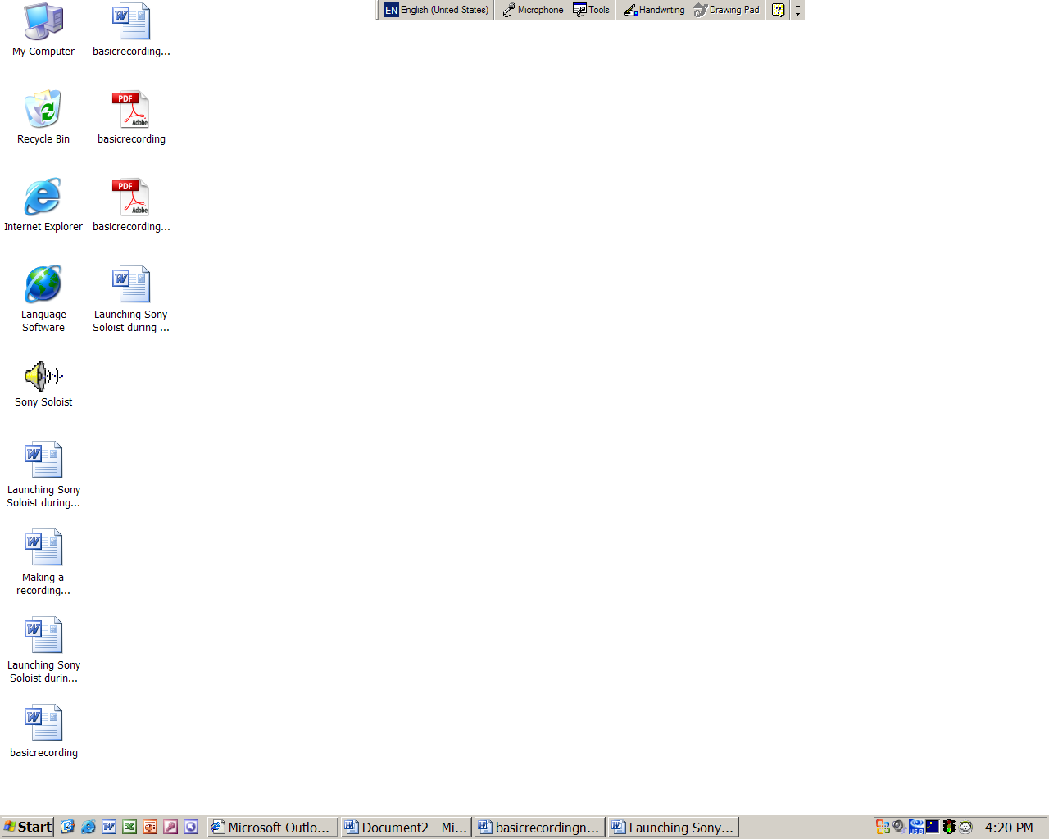

2. Once the Soloist Login window opens, TYPE YOUR NAME in the login box (no caps, no spaces, all one word... example: bartsimpson).

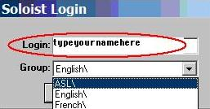

3. Select the LANGUAGE you wish to work on from the group menu (this is very important if you have a file to record & save).

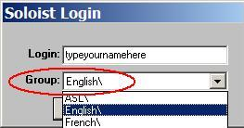

4. Once you have typed your name and selected the correct language, click on OK to launch Soloist.
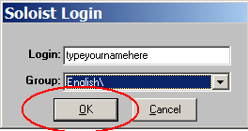

5. If you are visiting the lab with your class and instructor, click on ATTEND. You do not have to click on attend if you visit the lab on your own during the open lab hours and you are not in the room with your instructor.

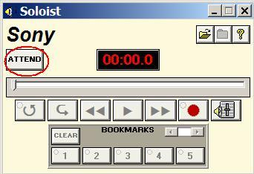

6. You can start recording, and after, save your work if you need to.

How do I start recording?

Once you’re certain the program is running and you have your headset & microphone ready, be prepared to start speaking! When you know what you are going to say, left-
click once on the red record button.

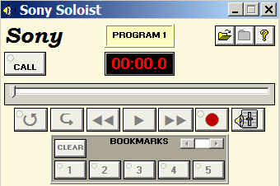

Note that when you start recording the play button becomes the stop button. You can stop in the middle of the recording process at any time by clicking on the stop button. You can now save your recording, keep recording from where you left off, or you can start over.

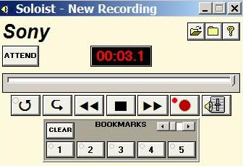

How do I listen to what I have recorded?

Once you stop the recording, the stop button becomes the play button again! Left-click once on the play button, and your recording begins to play.

What if I made a mistake or don’t like my recording?

No problem! Just left-click once on the ‘close file’ icon in the upper right of the Sony Soloist window. Then, in the small window that appears, left-click once to choose NO. Now, you are back to the beginning and ready to make your recording again. You can do this as many times as necessary!

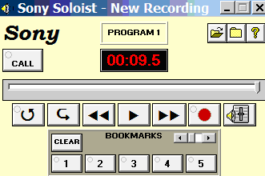
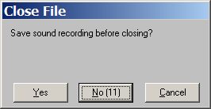

I am finished and I like my recording. How do I save it?

- To save your file, left-click once on the ‘close file’ icon. Now, choose YES to permanently save your recording. A new window, the dropbox, will open.

2. To save your work to the DROPBOX find your teacher’s name in the pull-down list.

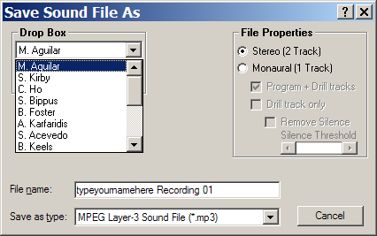

3. Once you have selected your teacher’s name left-click once on the pink ‘Save in Drop Box’ button. After clicking on the pink button another window will appear. This is the confirmation window where you save your recording or you cancel the saving process. If you want to save your recording left-click on the OK button.

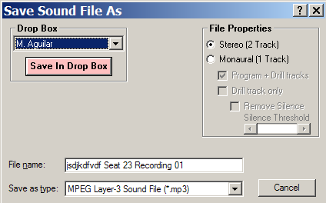
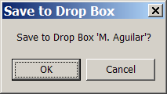

Note: If you have selected another teacher by mistake or simply want to cancel saving your recording left-click on CANCEL to go back to the previous screen.

Sony Soloist will convert your recording to an appropriately formatted computer file, and you’re done! After saving, Sony Soloist will return you to the same window you arrived at when you began. Remove your headphones, and place them back where they were at the beginning of the session. Please ask your instructor or the lab coordinator on duty for any further help with Sony Soloist!

-Happy recording!

Note: Once you are finished, don’t restart the computer, just CLOSE Sony Soloist, making sure to LEAVE THE STATION IN THE NEAT CONDITION YOU FOUND IT (chair pushed in, programs closed, headphones on hook, mouse & keyboard arranged correctly). Thanks! ☺

