

Office 365 Download Instructions (Employee/Instructors)

1. **Visit** <http://office.com/teachers>
2. **Click** ,



1. Enter you LoneStar Employee email address and **click Sign Up**.

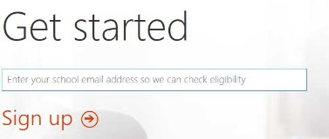

1. After clicking sign up check your LoneStar Employee email for the download link

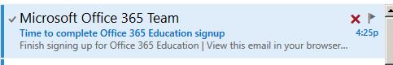

1. **Open** the Microsoft email and **click**



1. You then will be prompted to enter you first and last name, and create your own password. **Click** **start** once you have completed this.

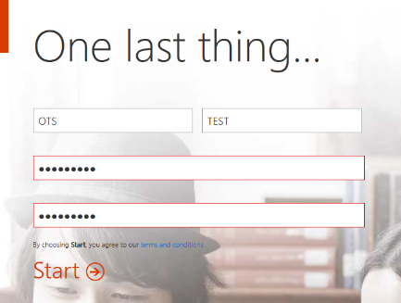

1. After your account logs in click **Install Now** .

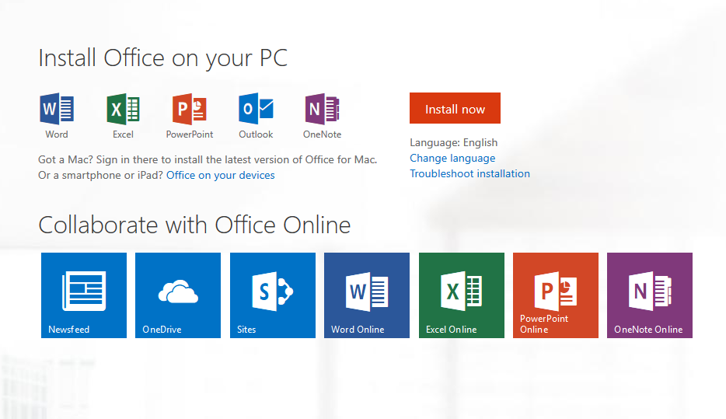

1. After clicking install now the following box will appear, click **run** this will install office 365 on your computer.

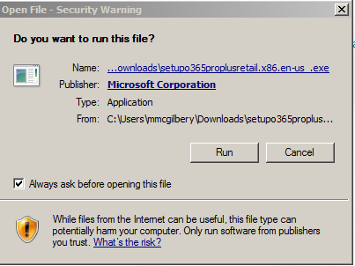

1. **Click** the Office 365 icon on your desktop or task bar



1. You can now use Office 365.