An International Education Event

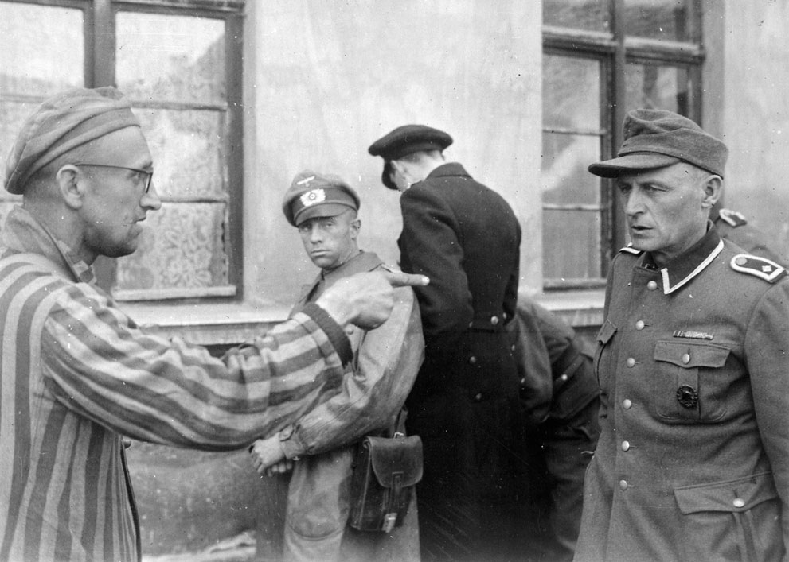

“Through Their Eyes: A Survivor’s Story.”

Nov. 19, 2014 -- Wed. 12:30pm -- in N-103

Come join Sandy Lessig in a presentation that allows her father to share his story of life in Germany under the rise of Nazism and Hitler. The project has been presented locally at schools, in corporate and organizational settings where a Holocaust Survivor has been asked to tell his or her testimony and is unable to appear. The story pioneers a way to authentically share both the Survivor’s experience and the important lessons they teach – to be carried on for the benefit of future generations.

Sponsored by the LSC-Tomball Language and Culture Center, Student Government Association, Honors College, Phi Theta Kappa, STARS, COTE and Faculty Senate.

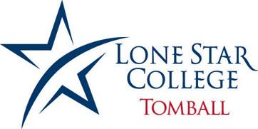
Language and Culture Center

