Academy for Lifelong Learning

Volunteer Instructor Guidelines

Thank you for sharing your time and expertise with our senior community. To keep our classes welcoming and consistent, please review these guidelines:

1. Purpose of Our Classes - Our volunteer-led classes are educational and community-focused, providing seniors a chance to learn, engage, and connect in a supportive environment.

2. Marketing and Solicitation - To maintain a non-commercial learning space:
- Class materials and discussions should focus on educational content only.
- Do not include promotional materials for personal businesses, programs, or coaching.
- Do not collect participant emails or add them to mailing lists without consent.
- If someone asks about your services, you may share your information privately after class.
- You may leave your business card on a table at the end of class for participants to take if they’re interested.

3. Handout Printing Guidelines - We provide printing for class materials within these limits:
- Up to 4 pages (2 double-sided sheets) per class, printed in black and white.
- Content must be class-related only (no promotional content).
- Please submit materials at least 1 week before your class

4. Communication and Respect
- Keep communication with participants focused on class topics unless they specifically ask for more information.
- Respect participant privacy and do not share their personal information.
- Notify us promptly if you need to cancel or reschedule.

5. Our Commitment to You - We value your contribution and will support you with classroom space, printing within guidelines, and basic logistics to help your class run smoothly.

Thank you for helping us create a positive, inclusive learning experience for our seniors!
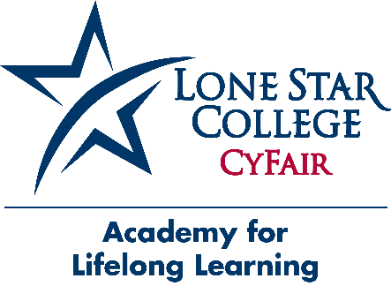
For questions or clarification, contact:
Amy Duval and Donna Gusman-Marsh
Lone Star College-CyFair, Academy for Lifelong Learning
Office: HSC1 (Building 9) Room 117-P
Telephone: 832.482.1067
Email: cf-academyforlifelonglearning@lonestar.edu

